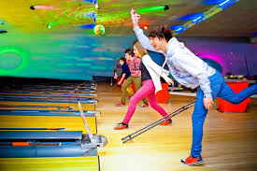  28th July  Ten Pin bowling  Our annual Ten Pin Bowls and pizza night is upon us. Get your bowling shoes on and pit your skills against your friends. Always a bit of fun for everyone involved. Pizza will be served afterwards back up at the clubrooms. It will be great to see as many people there as possible. R.S.V.P by the 25th July. | Ten Pin Bowling  ────  Pit your skills against your friends!  ────  28th July  ────  6:30 start  ────  R.S.V.P 25th July  Ten Pin Bowling alley and then back at the clubrooms for pizza.

